PS C:\terraform-staging> notepad .\provider.tf
PS C:\terraform-staging> aws ec2 describe-images --image-ids ami-0dc800c03e671a1e3 --region ap-sou
You write .tf files → Terraform talks to AWS → Creates infrastructure.
terraform.tfstate is a file where Terraform stores the current state of your infrastructure.
terraform import | Import existing AWS resources

terraform state list | List resources in state

terraform state show <resource> | Show details
terraform state show aws_vpc.staging_vpc

To install AWS CLI on Windows
- Download AWS CLI installer (latest version):
https://awscli.amazonaws.com/AWSCLIV2.msi
- Run the installer and complete setup. (Admin Username=./Neeraja-Admin pswd=Rock@123)
- Close & reopen Command Prompt, then check:
aws --version
(quick check )aws s3 ls / aws sts get-caller-identity
get from iam access key and secret key (don’t share)
aws configure
terraform installation : steps
Terraform Setup & AWS Import POC (Windows Machine)
1. Open PowerShell as Administrator(right click on powershell and open as admin)
2. Allow Execution Policy
Set-ExecutionPolicy Bypass -Scope Process -Force
3. Install Chocolatey
iwr https://community.chocolatey.org/install.ps1 -UseBasicParsing | iex
This installs Chocolatey package manager on Windows.
4. Add Chocolatey Path (if required)
setx PATH "$env:PATH;C:\ProgramData\chocolatey\bin"
Close & reopen PowerShell.
5. Install Terraform using Chocolatey
choco install terraform -y
Terraform gets installed system-wide & added to PATH automatically.
6. Verify Terraform Installation
terraform -version
Terraform 1.13.4
Terraform Project Setup : 1. Create Project Folder
mkdir terraform-import-poc
cd terraform-import-poc
2. Create provider.tf
notepad provider.tf
Paste:
provider "aws" {
region = "ap-southeast-1"
}

✅ 3. Initialize Terraform
terraform init
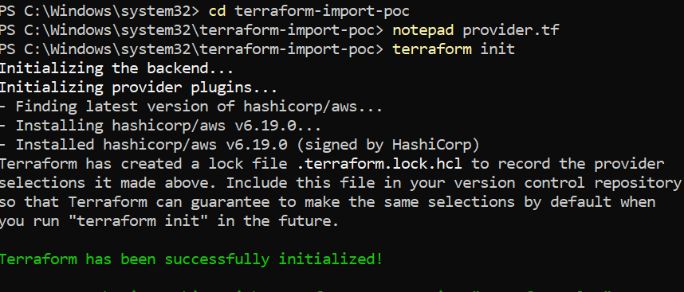
Step 1: Find Staging VPC ID
aws ec2 describe-vpcs --query "Vpcs[].{VpcId:VpcId,Name:Tags[?Key=='Name'].Value|[0]}" --output table
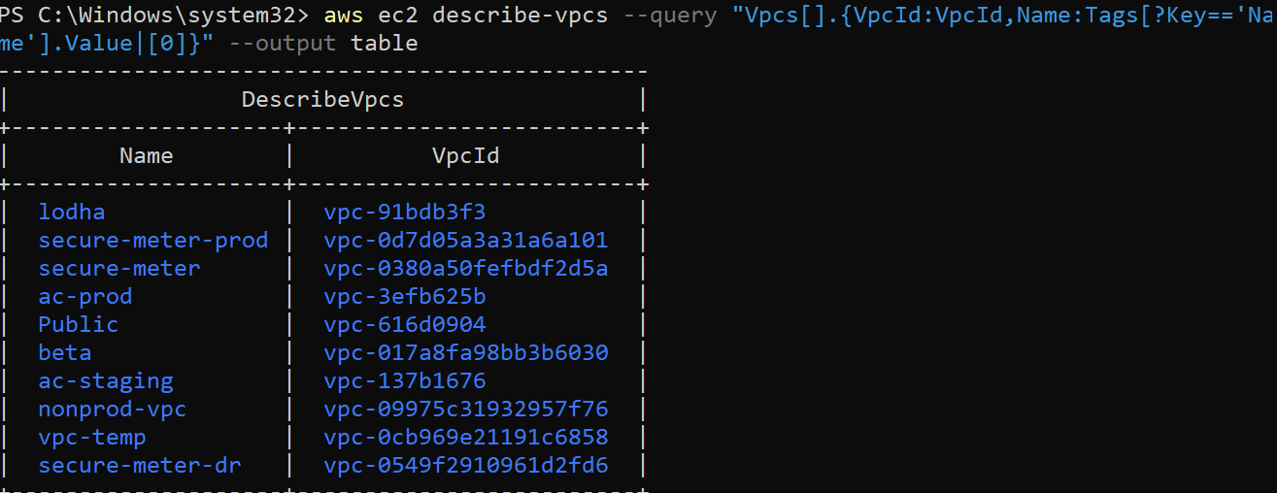
choosen
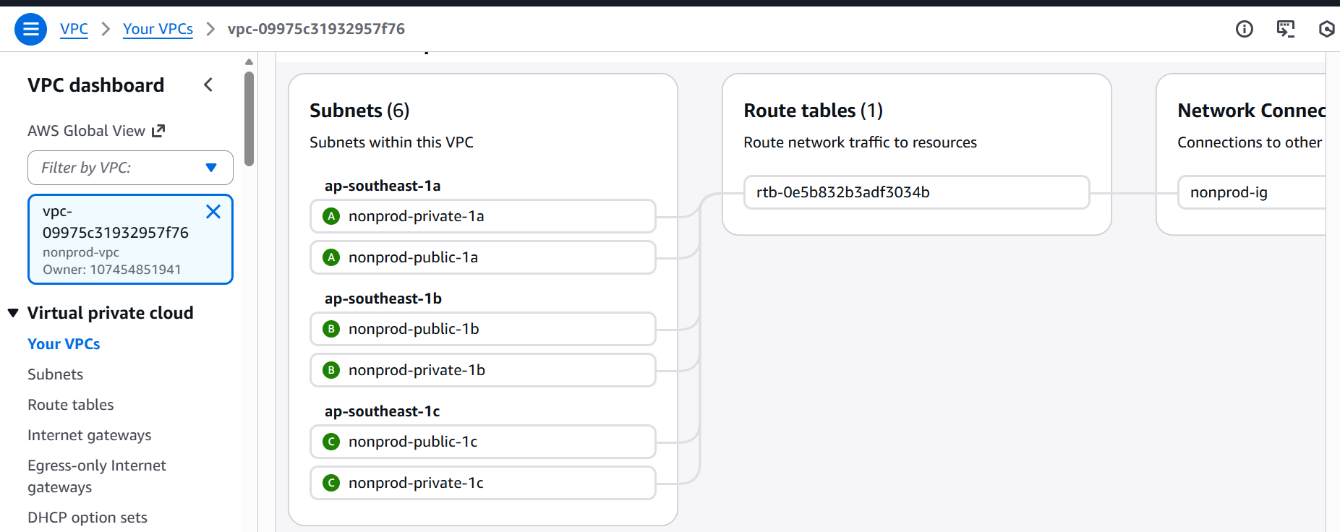 Step 2: Import the Staging VPC
Create vpc.tf:
notepad vpc.tf -- Add: resource "aws_vpc" "staging_vpc" {}
Import: terraform import aws_vpc.staging_vpc vpc-09975c31932957f76

✅ Step 3: Get all EC2 instances only in that VPC
aws ec2 describe-instances \
--filters "Name=vpc-id,Values= vpc-09975c31932957f76" \
--query "Reservations[*].Instances[*].InstanceId" \
--output text
See i-099efe2a907e108c1
i-05b91feff3ab33740
Create placeholder for EC2 imports
notepad staging-instances. -- paste it based on the number of instances we have.
resource "aws_instance" "staging1" {}
resource "aws_instance" "staging2" {}
(Use your instance IDs) save it
Import each instance
For each instance ID, run:
terraform import aws_instance.staging1 i-0aaa111
terraform import aws_instance.staging2 i-0bbb222

✅ Step 6: Validate Terraform state
terraform state list
After EC2, next step = Import Subnets
We will run:
aws ec2 describe-subnets --filters "Name=vpc-id,Values= vpc-09975c31932957f76" --query "Subnets[*].SubnetId" --output text
see
subnet-04812967ce4bf483b subnet-0d6a070b166ace1f8 subnet-0ae7bfa3146d683a9 subnet-054cbd6f5331042ef subnet-004f3382f66054698 subnet-0722f899e5d403675
Final Example Main.tf (for subnets only)
resource "aws_subnet" "subnet1" {}
resource "aws_subnet" "subnet2" {}
resource "aws_subnet" "subnet3" {}
resource "aws_subnet" "subnet4" {}
resource "aws_subnet" "subnet5" {}
resource "aws_subnet" "subnet6" {}
We will fill details later (like VPC ID, CIDR, AZ, tags)
Do not worry about missing arguments — this is expected during import phase.

After adding them
Run: terraform plan will see errors — ignore them.
Then import each subnet:

terraform import aws_subnet.subnet1 <subnet-id1>
terraform import aws_subnet.subnet2 <subnet-id2>
terraform import aws_subnet.subnet3 <subnet-id3>
terraform import aws_subnet.subnet4 <subnet-id4>
terraform import aws_subnet.subnet5 <subnet-id5>
terraform import aws_subnet.subnet6 <subnet-id6>

🎯 IMPORTANT NEXT
After import, run:
terraform state show aws_subnet.subnet1
How to show only instances from your VPC
Run this command by replacing vpc-xxxxxx with your VPC ID:
aws ec2 describe-instances --filters "Name=vpc-id,Values=vpc-xxxxxx" --query "Reservations[*].Instances[*].InstanceId" --output text (used to get only at that vpc)
terraform import aws_instance.staging1 i-099efe2a907e108c1
terraform import aws_instance.staging2 i-05b91feff3ab33740
Find the Internet Gateway
Run:
aws ec2 describe-internet-gateways --filters "Name=attachment.vpc-id,Values= vpc-09975c31932957f76" --query "InternetGateways[*].InternetGatewayId" --output text
igw-07264d18e8185d8a7
Add placeholder in main.tf
Open main.tf: notepad main.tf Add: resource "aws_internet_gateway" "main" {}
Import IGW
terraform import aws_internet_gateway.main igw-07264d18e8185d8a7
Find Route Tables
Run:
aws ec2 describe-route-tables --filters "Name=vpc-id,Values= vpc-09975c31932957f76" --query "RouteTables[*].RouteTableId" --output text
output: GatewayId: rtb-0e5b832b3adf3034b (OR natwaget way it will be like nat-1234 and keep the same if u have igw as public and nat if as private in main.tf)
Add placeholders in main.tf
resource "aws_route_table" "public" {}
Import them:
terraform import aws_route_table.public rtb-0e5b832b3adf3034b
terraform import aws_route_table.private rtb-bbb
Import Route Table Associations
First: Get association IDs
Run:
aws ec2 describe-route-tables --filters "Name=vpc-id,Values= vpc-09975c31932957f76" --query "RouteTables[*].Associations[*].[SubnetId,RouteTableAssociationId]" --output table
Output will look like:
SubnetId | RouteTableAssociationId
subnet-aaa | rtbassoc-111
subnet-bbb | rtbassoc-222
... | ...
Copy these.

In main.tf add placeholders
Open file:
notepad main.tf
Add:
resource "aws_route_table_association" "subnet1" {}
resource "aws_route_table_association" "subnet2" {}
resource "aws_route_table_association" "subnet3" {}
resource "aws_route_table_association" "subnet4" {}
resource "aws_route_table_association" "subnet5" {}
resource "aws_route_table_association" "subnet6" {}
Save ✅

Now import each association
Example (replace IDs): be careful replace rtb not rtbssoc ,

terraform import aws_route_table_association.subnet1 subnet-0ae7bfa3146d683a9/rtb-0e5b832b3adf3034b
terraform import aws_route_table_association.subnet2 subnet-054cbd6f5331042ef/rtb-0e5b832b3adf3034b
terraform import aws_route_table_association.subnet3 subnet-04812967ce4bf483b/rtb-0e5b832b3adf3034b
terraform import aws_route_table_association.subnet4 ubnet-0722f899e5d403675/rtb-0e5b832b3adf3034b
terraform import aws_route_table_association.subnet5 subnet-004f3382f66054698/rtb-0e5b832b3adf3034b
terraform import aws_route_table_association.subnet6 subnet-0d6a070b166ace1f8/rtb-0e5b832b3adf3034b
Filter by VPC & EC2 & Unique list
aws ec2 describe-instances --filters "Name=vpc-id,Values=<your-vpc-id>" --query "Reservations[*].Instances[*].[InstanceId,SecurityGroups[*].GroupId]" --output table
aws ec2 describe-instances --filters "Name=vpc-id,Values=<your-vpc-id>" --query "Reservations[*].Instances[*].SecurityGroups[*].GroupId" --output text | Sort-Object -Unique
notepad main.tf
past
resource "aws_security_group" "sg1" {}
resource "aws_security_group" "sg2" {}
import:
terraform import aws_security_group.sg1 sg-01cd216ce2a571e33
terraform import aws_security_group.sg2 sg-0586a0e02e9200709
-----
ok now what happened is i dont have a new ec2 instance i want to use vpc ac-staging in that i have my ec2 its name is devn . i want to clone the instance by using terraform that generated instance i will use for automation is that ok # we have terraform in our windows where previous i used is that ok can you slove it

Step 1 — Identify your devn EC2 parameters

C:\terraform-staging aws ec2 describe-instances --filters "Name=tag:Name,Values=devn" --query "Reservations[*].Instances[*].[InstanceId,ImageId,InstanceType,SubnetId,SecurityGroups[*].GroupId]" --output table
---------------------------
| DescribeInstances |
| i-0f53249af8945864b |
| ami-0dc800c03e671a1e3 |
| t3a.medium |
| subnet-259fc140 |
| sg-5dbcb538 |
Step 1 — Identify your devn EC2 parameters
aws ec2 describe-instances --filters "Name=tag:Name,Values=devn" --query "Reservations[*].Instances[*].[InstanceId,ImageId,InstanceType,SubnetId,SecurityGroups[*].GroupId]" --output table
Step 2 — Create Terraform file for new EC2
In your Windows terraform project folder, create automation-ec2.tf
Example template (fill values):
resource "aws_instance" "automation" {
ami = "ami-xxxxx" # from describe command HERE I FACED A ISSUE THAT AMI ID MUST BE TAKEN IN IMAGES OF THE SERVER.not from the given values by the above cmd.
instance_type = "t3.micro" # or same as devn
subnet_id = "subnet-xxxxx"
vpc_security_group_ids = [
"sg-xxxxx",
"sg-yyyyy"
]

tags = {
Name = "automation-ec2" #HERE GIVE THE NAME YOU WANT TO SEE NAME ON AWS INSTANCES
}
} #This creates a new EC2 in your staging VPC

Step 3 — Initialize & apply Terraform
terraform init
terraform plan
DON’T DO THIS
Do not terraform import your devn server
Do not copy EBS snapshot unless necessary (not needed for automation machine)
Do not use Windows laptop for cron automation.
Take ami number from the images , then do not destroy anything with out check the plan and see one plan add + and check the destroy are 0 only if you have anyother number 1 or 2 do not approve only when you have destroy are 0 only approve.
After EC2 is created
SSH into new automation EC2: ssh ec2-user@<public-ip>

